

BRANCH WEBSITE: http://branches.asce.org/wichita

CALEB COLTRANE, PRESIDENT
Garver♦ 316-221-3022♦ crcoltrane@garverusa.com

MACEE CROWELL, VICE PRESIDENT
Kirkham Michael ♦ 316-303-3026♦ mcrowell@kirkham.com

DAKOTA McKEE, TREASURER
Gannett Fleming TranSystems ♦ 316-303-3051♦ dmmckee@transystems.com

ALLISON ATKINSON, SECRETARY
U.S. Geological Survey ♦ 317-682-7977♦ aatkinson@usgs.gov

SCOTT LINDEBAK, PAST PRESIDENT
Sedgwick County ♦ 316-660-1754♦ scott.lindebak@sedgwick.gov

ASCE April Meeting Minutes

Speakers: Jessie Garrison, Asphalt Operations Manager
Topic: ASCE Wichita Branch and WSPE Joint Site Tour
Date: Wednesday, April 16, 2025
Location: Pearson Construction, LLC
Asphalt Plant
3600 N West Street, Wichita, KS 67205

President Caleb Coltrane called the meeting to order at about 12:00 pm.

Announcements
- Hands on engineering will be happening each month and Garver is volunteering on May 3rd.

The speaker was introduced. Jessie Garrison is the Asphalt Operations Manager at the Pearson Asphalt plant. He has worked as a heavy equipment operator, a laboratory technician, and as the asphalt operations manager. Jessie has been in the paving business since the 1990s.

Site Tour Notes

WSPE and ASCE members arrived onsite at about 11:45-am. Members ate lunch before beginning the tour led by Jessie Garrison. The plant tour followed the typical progression of asphalt manufacturing beginning with the aggregate piles on the north side of the plant, progressing through the heating, drying, and mixing locations, and terminating at the storage and dispatch area. The plant uses both recycled asphalt and new aggregates and is capable of creating a variety of mixes. The baghouse dust collector and bitumen supply systems were also identified on the tour. Trucks sit on scales to be loaded and the quantity of asphalt delivered to the truck is determined based on the changing weight of the truck.

The tour also included a visit to the control center. The entire plant can be controlled from this area. From this location, operators can precision load asphalt trucks by slowly releasing a small amount of asphalt into the truck at a time. Typically, this practice is done for smaller orders. They are also able to view the entire plant with cameras.
The Pearson Asphalt Plant was built in the 1990s with the goal of servicing the majority of Wichita’s asphalt needs all at once. Shortly after the plant was constructed, a production run was completed at full capacity. However, the plant usually runs at approximately half capacity. The plant can store asphalt for about three days, but it depends on the mix. Sometimes, the asphalt on the edges of the storage cylinder will burn because it is close to the heat source and will have to be discarded.

Meeting adjourned by President Caleb Coltrane at about 1:00 p.m.

Minutes respectfully submitted by Secretary Allison Atkinson.

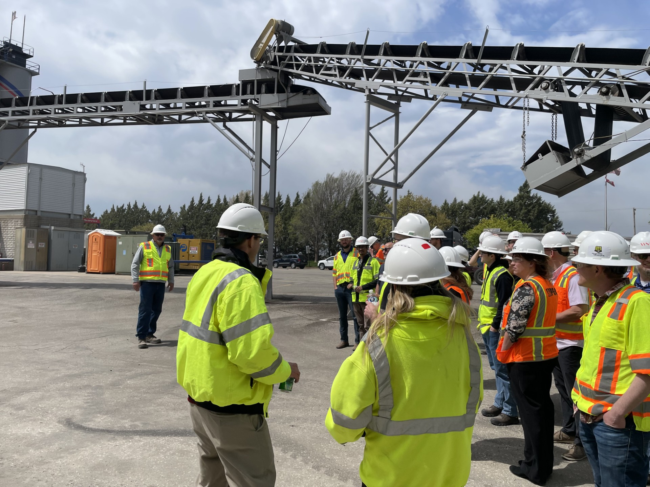

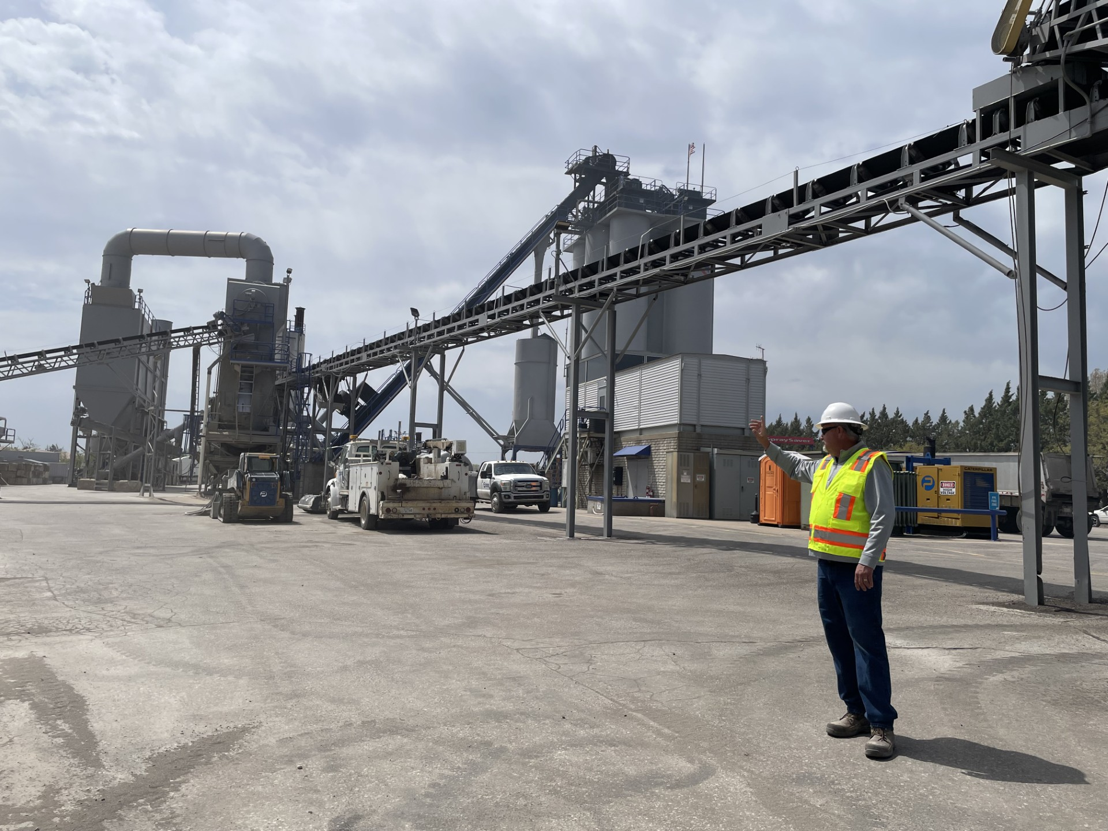

Meeting Attendees

1 | Shane | Albritton
2 | Makenzie | Allen
3 | Austin | Amershek
4 | Saldeldeen | Antar
5 | Eric | Armstrong
6 | Debra | Ary
7 | Allison | Atkinson
8 | Scott | Bernhardt
9 | Sangeeta | Bhattacharjee
10 | Eric | Bradley
11 | Paul | Cater
12 | Caleb | Coltrane
13 | Macee | Crowell
14 | Jake | Exley
15 | Harlan | Foaker
16 | Traci | Grant
17 | John | Heinz
18 | Sadiksha | Katwal
19 | Kaden | Kisner
20 | Ben | Mabry
21 | Dakota | McKee
22 | Nikki | McMinn
23 | Logan | Mills
24 | Shavon | Morgan
25 | Behrooz | Rahbar
26 | Jennifer | Salvo
27 | Kanchan | Sapkota
28 | Matt | Schultze
29 | Daniel | Schrant
30 | Andrew | Sheridan
31 | Michael | Snapp
32 | Hunter | Wiles

