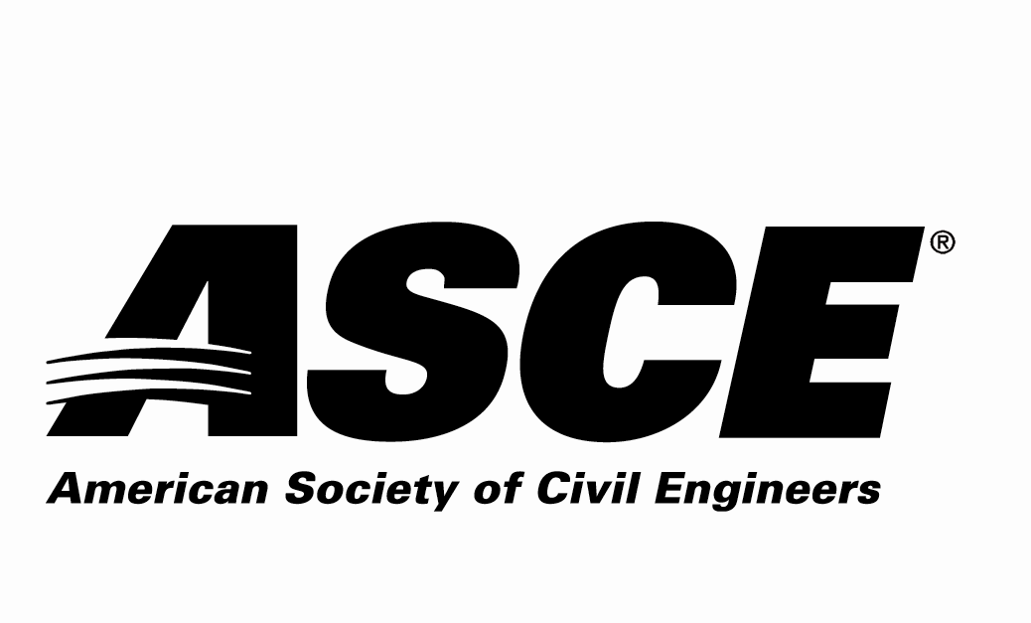 | Kansas Section

Individual Nomination Form

Outstanding ASCE Student Member Award

Due Date: Nominations must be received by March 16, 2026

Application Materials Required
Individual Nomination Form and Electronic Photo of Nominee

Entry Instructions
Electronic submittal is requested. Please e-mail the following 2 electronic files (less than 10 MB per e-mail):
- File 1: Filename = nominee’s last name.pdf
Individual Nomination Form
- File 2: Filename = nominee’s last name.jpg
Photo of the nominee to be used in the awards program

E-mail to: asce.ks.section@gmail.com with the Subject line name of:
“ASCE KS Award Application – Outstanding ASCE Faculty/Practitioner Advisor for (nominee’s last name)”

For more information contact:
Scott Lindebak - ASCE KS Section Awards Committee
asce.ks.section@gmail.com,
Scott.Lindebak@sedgwick.gov or 316-660-1754

Award Criteria
• Student must be a national ASCE member and a student chapter member in good standing at the time of application
• Student must have demonstrated extraordinary leadership in a Student Chapter through various activities (e.g., serving as a chapter officer, leading special events, interacting with university administration and ASCE Sections/Branches)
• Nomination must come from the Faculty or Practitioner Advisor, Department Head, or Section/Branch Officer.
• Only one nomination will be accepted from each student chapter
• Student must be an undergraduate at the nominating school during the award year.

Awards Ceremony
The selected individual will be recognized at the ASCE KS Joint Banquet Dinner on March 31st, 2026.

The Award
The award is intended to recognize the efforts of student civil engineers who have demonstrated outstanding leadership to their ASCE student chapter.

Nominator Contact Information (person making the nomination – self-nomination encouraged)
Name:
Employer:
Address:
 | Street |  |  | City | State | Zip
Phone Number:
Email Address:
ASCE Membership#:

Nominee Contact Information
Name:
Employer:
Address:
 | Street |  |  |  | City |  | State | Zip
Phone Number:
Email Address:

Nominee ASCE Membership Information:

ASCE Student Chapter nominee belongs to:
Kansas Section
Wichita Branch
Nomination Information Section:
Please answer the following questions as thoroughly as possible and ensure that the response to this nomination information section is three pages or less.

1. Describe the nominee’s ASCE involvement.

2. Describe the nominee’s other Student Leadership activities.

3. Describe the nominee’s contributions to the Community.

4. Provide any other information regarding the nominee to be considered for this award.

