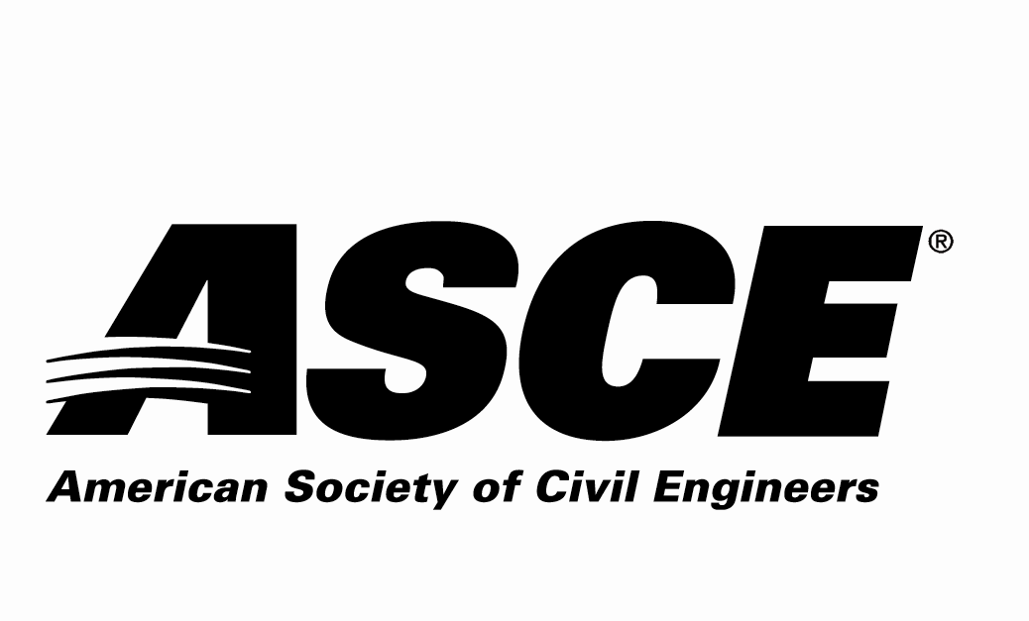 | Kansas Section

Individual Nomination Form

Professional Progress Award

Due Date: Nominations must be received by March 16, 2026

Application Materials Required
Individual Nomination Form and Electronic Photo of Nominee

Entry Instructions
Electronic submittal is requested. Please e-mail the following 2 electronic files (less than 10 MB per e-mail):
- File 1: Filename = nominee’s last name.pdf
Individual Nomination Form
- File 2: Filename = nominee’s last name.jpg
Photo of the nominee to be used in the awards program

E-mail to: asce.ks.section@gmail.com with the Subject line name of:
“ASCE KS Award Application – Outstanding ASCE Faculty/Practitioner Advisor for (nominee’s last name)”

For more information contact:
Scott Lindebak - ASCE KS Section Awards Committee
asce.ks.section@gmail.com,
Scott.Lindebak@sedgwick.gov or 316-660-1754

Award Criteria
This award is intended to recognize the lifetime efforts of civil engineers service to further advance the field of civil engineering through their contributions, innovative concepts, research, and materials. The nominee for this award shall be a Registered Professional Engineer and be a member of ASCE in Region 7.

Awards Ceremony
The selected individual will be recognized at the ASCE KS Joint Banquet Dinner on March 31st, 2026.

Nominator Contact Information (person making the nomination – self-nomination encouraged)
Name:
Employer:
Address:
 | Street |  |  | City | State | Zip
Phone Number:
Email Address:
ASCE Membership#:
P.E.? Yes or No

Nominee Contact Information
Name:
Employer:
Address:
 | Street |  |  |  | City |  | State | Zip
Phone Number:
Email Address:
P.E. Registration State |  |  |  | P.E. Registration #

Nominee ASCE Membership Information:
ASCE Section nominee belongs to:
Kansas Section
Wichita Branch

Professional Progress Nomination Information Section:
Please answer the following questions as thoroughly as possible and ensure that the response to this nomination information section is 3 pages or less.

1. Describe the nominee’s ASCE involvement.

2. Describe the nominee’s other professional activities.

3. Describe the nominee’s contributions to the Civil Engineering Profession.

4. Provide any other information regarding the nominee to be considered for this award.

