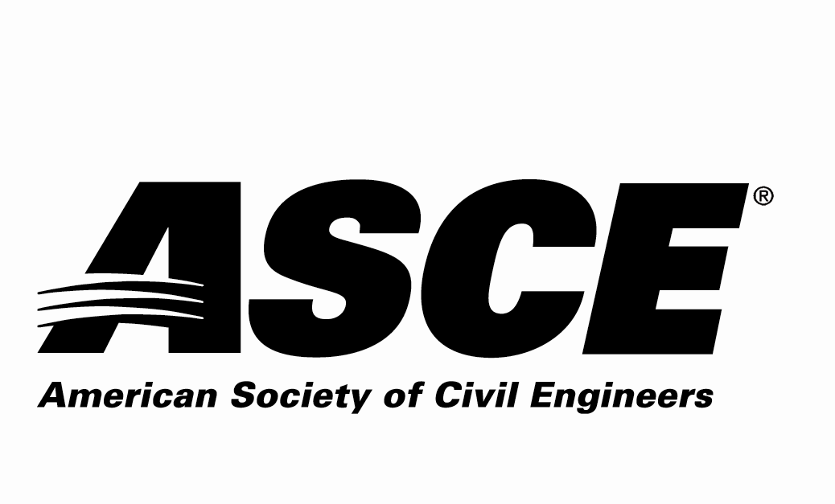 | Kansas Section

Individual Nomination Form

Outstanding ASCE Younger Member Award

Due Date: Nominations must be received by March 16, 2026

Application Materials Required
Individual Nomination Form and Electronic Photo of Nominee

Entry Instructions
Electronic submittal is requested. Please e-mail the following 2 electronic files (less than 10 MB per e-mail):
- File 1: Filename = nominee’s last name.pdf
Individual Nomination Form
- File 2: Filename = nominee’s last name.jpg
Photo of the nominee to be used in the awards program

E-mail to: asce.ks.section@gmail.com with the Subject line name of:
“ASCE KS Award Application – Outstanding ASCE Faculty/Practitioner Advisor for (nominee’s last name)”

For more information contact:
Scott Lindebak - ASCE KS Section Awards Committee
asce.ks.section@gmail.com,
Scott.Lindebak@sedgwick.gov or 316-660-1754

Award Criteria
Consideration shall be given to the Engineer who has exhibited professional achievement and has made a significant impact in the field of civil engineering. This impact may be through professional activities, ASCE involvement, research, and innovative engineering solutions. This award is intended for individuals who are age 35 years or less as of December 1 of the year of the award and a member of ASCE in Region 7.

Awards Ceremony
The selected individual will be recognized at the ASCE KS Joint Banquet Dinner on March 31st, 2026.

The Award
The award is intended to recognize the efforts of younger civil engineers to further advance the field of civil engineering through innovative concepts, research, and materials.

Nominator Contact Information (person making the nomination – self-nomination encouraged)
Name:
Employer:
Address:
 | Street |  |  | City | State | Zip
Phone Number:
Email Address:
ASCE Membership#:
P.E.? Yes or No

Nominee Contact Information
Name:
Employer:
Address:
 | Street |  |  |  | City |  | State | Zip
Phone Number:
Email Address:
P.E. Registration State |  |  |  | P.E. Registration #

Nominee ASCE Membership Information:
ASCE Section nominee belongs to:
Kansas Section
Wichita Branch

Nomination Information Section:
Please answer the following questions as thoroughly as possible and ensure that the response to this nomination information section is three pages or less.

1. Describe the nominee’s ASCE involvement.

2. Describe the nominee’s other professional activities.

3. Describe the nominee’s contributions to the profession.

4. Provide any other information regarding the nominee to be considered for this award.

